AWS Project – 001

VPC with Public-Private Subnet in Production

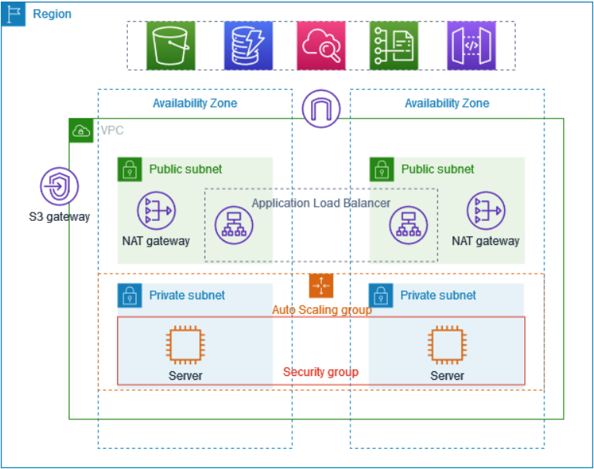
VPC Public-Private Architecture

• Internet Gateway → for public internet access
• NAT Gateway → outbound internet access for private subnets not inbound instance access from internet.
• S3 VPC Endpoint (Gateway) → private, secure access to S3 (Simple Storage Service)

About the Project
This Project demonstrates how to create a VPC that we can use for servers in a production environment.
To improve resiliency (flexibility), we deploy the servers in two Availability Zones, by using an Auto Scaling group and an Application Load Balancer. For additional security, you deploy the servers in private subnets. The servers receive requests through the load balancer. The servers can connect to the internet by using a NAT gateway. To improve resiliency, you deploy the NAT gateway in both Availability Zones.

Key Concepts
- Auto Scaling Group: automatically adds, removes, and replaces servers.
- Application Load Balancer: intelligently distributes user requests across those servers.
- Bastion Host: A Bastion Host (also called a Jump Server) is a secure administrative server used to access instances located in private subnets (Inbound Instance Access).
- Target Group: An AWS resource that defines and monitors the backend targets (such as EC2 instances) to which a load balancer forwards traffic.

Overview
The VPC has public subnets and private subnets in two Availability Zones.
Each public subnet contains a NAT gateway and a load balancer node.
The servers run in the private subnets, are launched and terminated by using an Auto Scaling Group (ASG), and receive traffic from the load balancer.
The servers can connect to the internet by using the NAT gateway.

Inbound vs Outbound Traffic
- Outbound traffic:
When the EC2 instance itself goes out to the internet to get something.
Example: EC2 downloading updates, software, or calling an external API.
- Inbound traffic:
When someone on the internet tries to come into the EC2 instance without the EC2 asking first.
Example: Trying to SSH or access a private EC2 directly from the internet.
Key clarification
- Private subnet:
  - EC2 can go to the internet (outbound)
  - Internet cannot come to the EC2 by itself (inbound)

